Conference fee self-help guide
- Register your account at the following website https://pay.shu.edu.cn/SPPMain
Or you could go to the website of the Finance Department of Shanghai University and choose the "online payment platform" in the upper left corner.
- Re-login https://pay.shu.edu.cn/SPPMain after registration, select
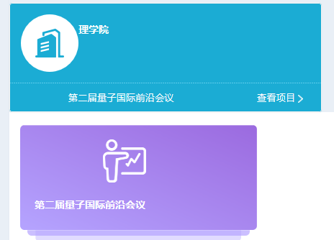
- Check the appropriate fee and the number of persons, and then click "Pay" after confirming the number of people.
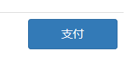
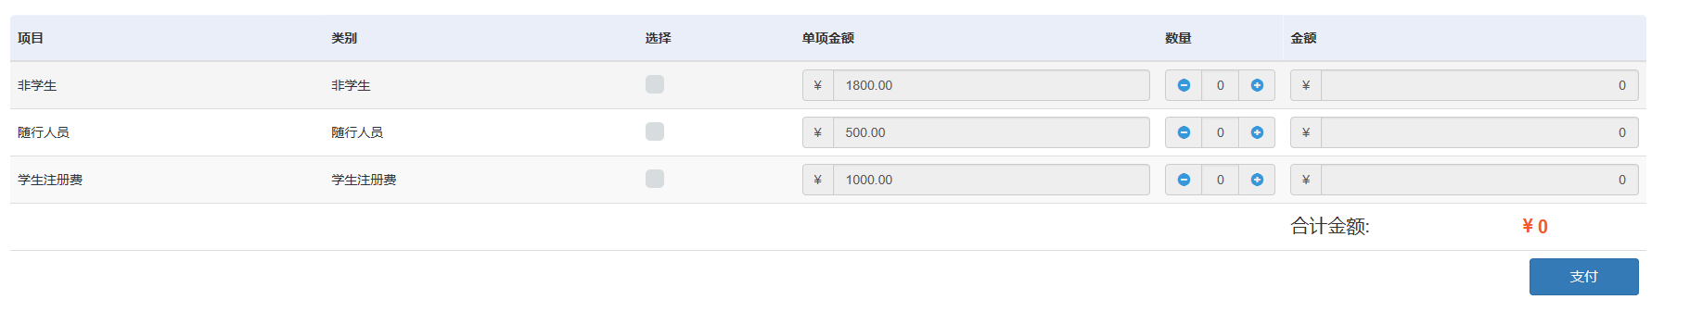
Note:
Early-fee, before 9.30: students(学生)-1000RMB; regular participants（非学生）-1800RMB; accompanying persons(随行人员)-500RMB
Regular fee, after 9.30: students(学生)-1300RMB; regular participants（非学生）-1800RMB; accompanying persons(随行人员)-500RMB
On site: students（学生）-1500RMB; regular participants（非学生）-2500RMB; accompanying persons（随行人员）-500RMB

- Fill in the corresponding information (Note: Check "Electronic Invoice" for the type of invoice, do not choose "individual" for reimbursement, and the electronic invoice will be sent to the mailbox filled in).
